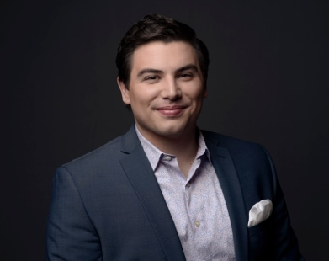
Eric Ferring
Tenor

Tenor Eric Ferring, a native of Dubuque, Iowa, is an alum of Drake University and The Boston Conservatory under the tutelage of Dr. Rebecca Folsom.

Mr. Ferring is currently in the Ensemble of the Ryan Opera Center at the Lyric Opera of Chicago having performed Lurcanio/Ariodante, Young Servant/Elektra, and Giuseppe/Gastone in La traviata this past season and will sing roles in Dead Man Walking and Queen of Spades next season.

Previously, Mr. Ferring was a Resident Artist at Pittsburgh for two seasons where he performed multiple roles including The Protagonist in the world premiere of Ashes & Snow (now known as Savage Winter) in collaboration with American Opera Projects, Flask/Moby-Dick, and Nemorino/L’elisir d’Amore, In the summer of 2017, Mr. Ferring was an Apprentice Singer at Santa Fe Opera where he covered Oronte/Alcina and was awarded the Richard Tucker Memorial Scholarship. Mr. Ferring will return to Santa Fe for his principal role debut singing Tamino in Die Zauberflöte in summer of 2020.

He has also been seen at Opera Theatre of Saint Louis, Wolf Trap Opera, Seagle Music Colony, Cedar Rapids Opera Theatre, and Lakes Area Music Festival. In addition, Mr. Ferring was a recipient of a 2018 Sara Tucker Study Grant from the Richard Tucker Foundation, as well as a Career Grant from the Sullivan Foundation, Third Prize in the 2017 Gerda Lissner Foundation International Voice Competition, Top Prize in the American Opera Society of Chicago competition, and a Regional Encouragement Award at the 2017 Great Lakes Region of the Metropolitan Opera National Council Audition. In 2015, Opera Theatre of Saint Louis presented Mr. Ferring a career award from the Richard Gaddes Fund for Young Artists given in recognition of his great vocal potential.

Mr. Ferring will attend the Britten-Pears Young Artist Programme, the Académie du Festival d’Aix, and the Verbier Festival this summer where he will perform recitals, concerts, a supporting role in Die Frau ohne Schatten, and perform his role debut of Tamino in Die Zauberflöte.

Mr. Ferring is managed by Fletcher Artist Management. For further materials and updates, please visit Mr. Ferring’s website at ericferring.com or his professional Facebook page.

